Team Profile

Each group member's tests that were completed in assignment 1 have been listed below.

**Robert Cross**

*Meyer-Briggs Test*

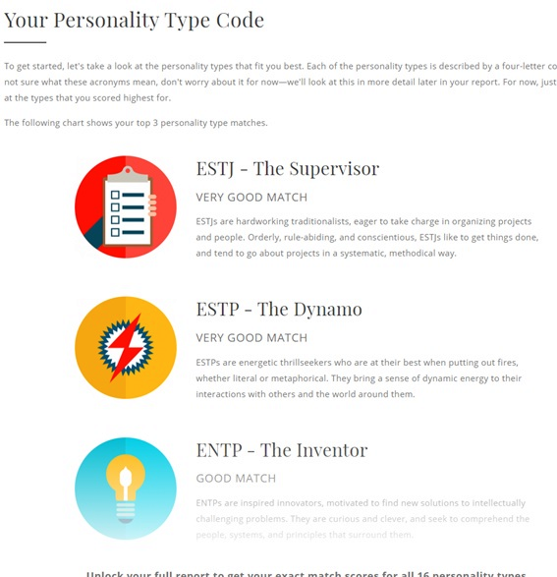

*Personality test*

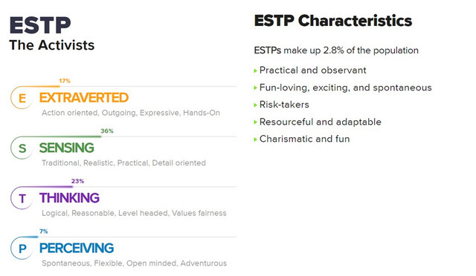

*Numeracy Test*

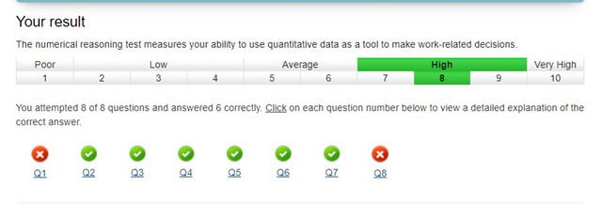

**Ryan Williams**

*Meyer-Briggs Test*

[*https://www.16personalities.com/profiles/2b0ec0d4ce2f1*](https://www.16personalities.com/profiles/2b0ec0d4ce2f1)

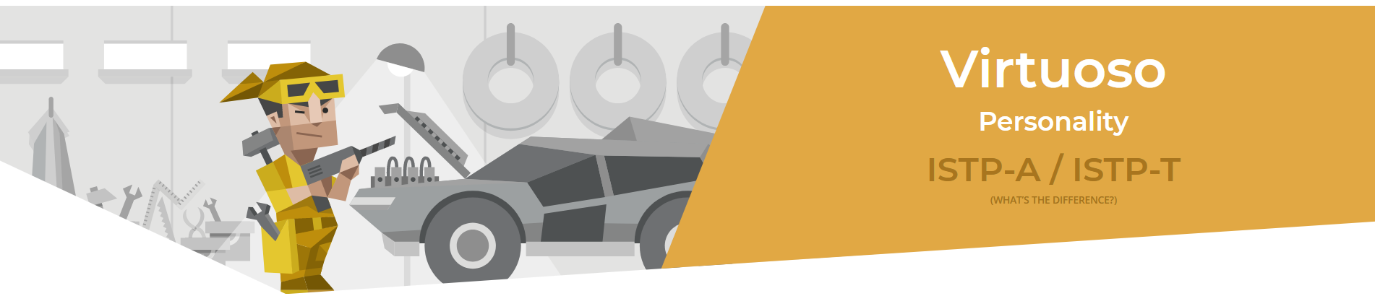

*Learning style Test*

[*https://ryan-williams1.github.io/IIT/Learning_Style_Results.pdf*](https://ryan-williams1.github.io/IIT/Learning_Style_Results.pdf)

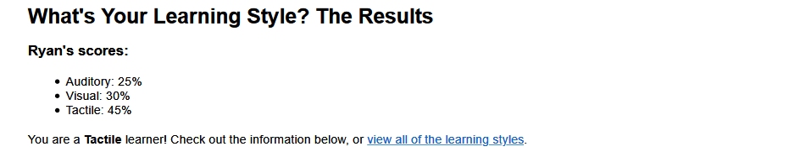

*Psychometric Test*

[*https://www.carecareers.com.au/quiz/result/id/1354786/token/6f539e2e#.XpmP6JnhWUl*](https://www.carecareers.com.au/quiz/result/id/1354786/token/6f539e2e#.XpmP6JnhWUl)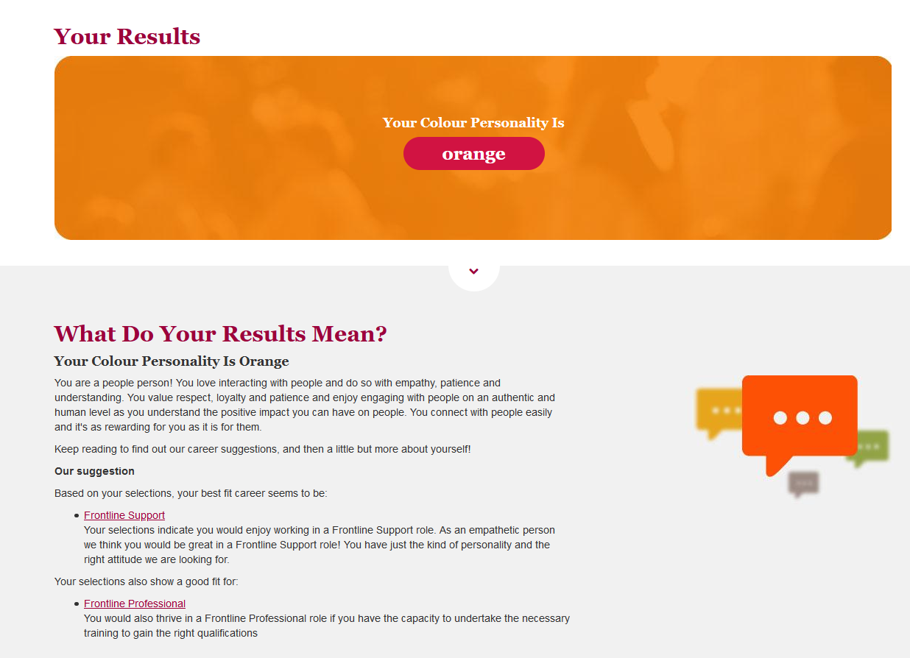

**Benjamin King**

*Myer-Briggs Test*

[*https://www.16personalities.com/infj-personality*](https://www.16personalities.com/infj-personality)

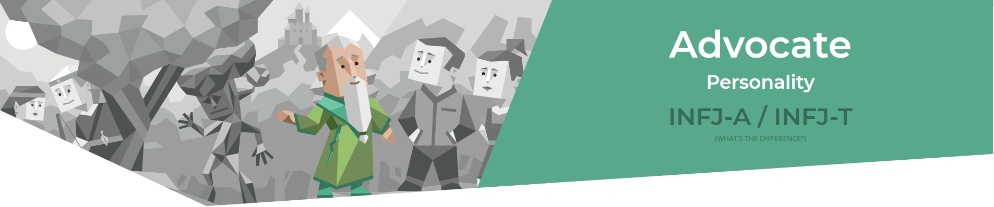

*Learning Style test*

[*http://www.educationplanner.org/students/self-assessments/learning-styles-quiz.shtml?event=results&A=7&V=6&T=7*](http://www.educationplanner.org/students/self-assessments/learning-styles-quiz.shtml?event=results&A=7&V=6&T=7)

*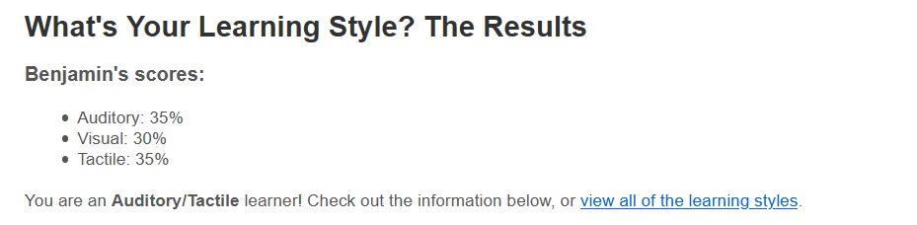Big 5 Personality Test*

[*https://www.truity.com/test/big-five-personality-test*](https://www.truity.com/test/big-five-personality-test)

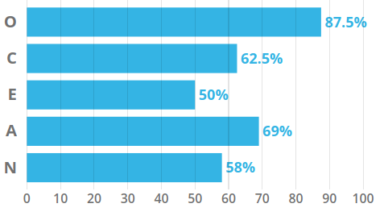

**Douglas Baker**

*Myer-Briggs Test*

[*https://www.16personalities.com/istj-personality*](https://www.16personalities.com/istj-personality)

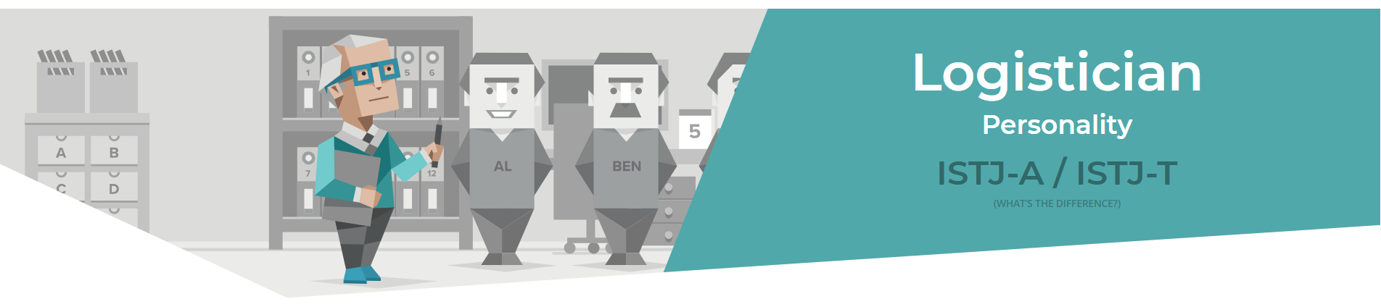

*Myer-Briggs/Jung test*

[*http://www.humanmetrics.com/*](http://www.humanmetrics.com/)

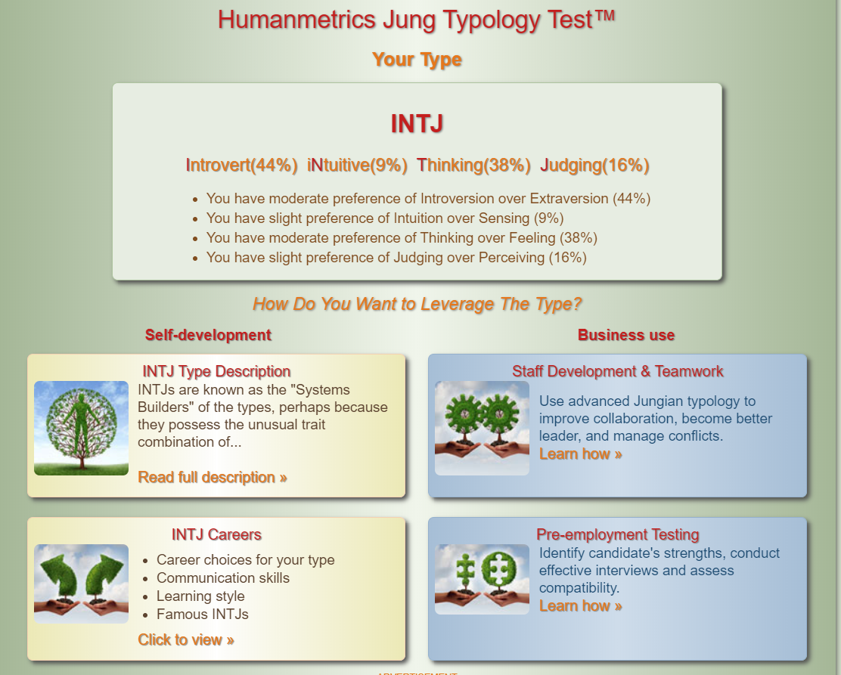

*Big 5 Personality Test*

[*https://www.truity.com/test/big-five-personality-test*](https://www.truity.com/test/big-five-personality-test)

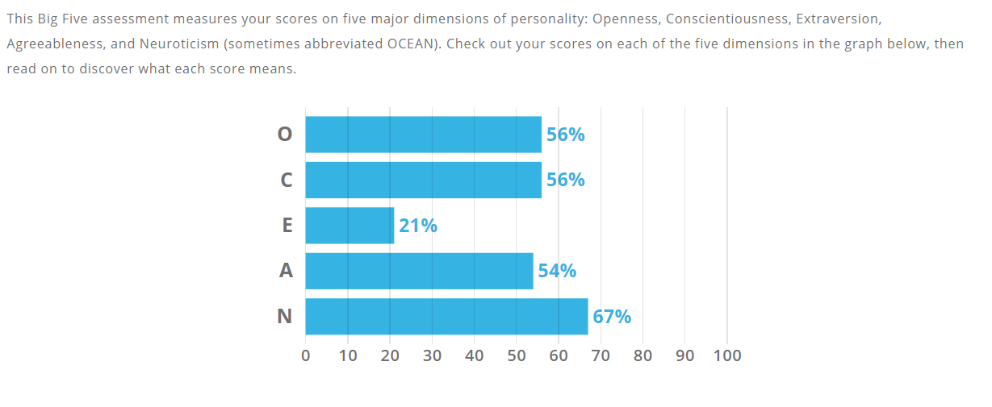

**Ty Lynch**

*Myer-Briggs Test*

[*https://www.16personalities.com/istj-personality*](https://www.16personalities.com/istj-personality)

**

*Learning Style Test*

[*http://www.educationplanner.org/students/self-assessments/learning-styles-quiz.shtml?event=results&A=6&V=9&T=5*](http://www.educationplanner.org/students/self-assessments/learning-styles-quiz.shtml?event=results&A=6&V=9&T=5)

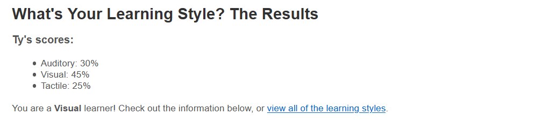

*Big 5 Personality Test*

[*https://www.scienceofpeople.com/personality-quiz-results/?score=386050647.14*](https://www.scienceofpeople.com/personality-quiz-results/?score=386050647.14)

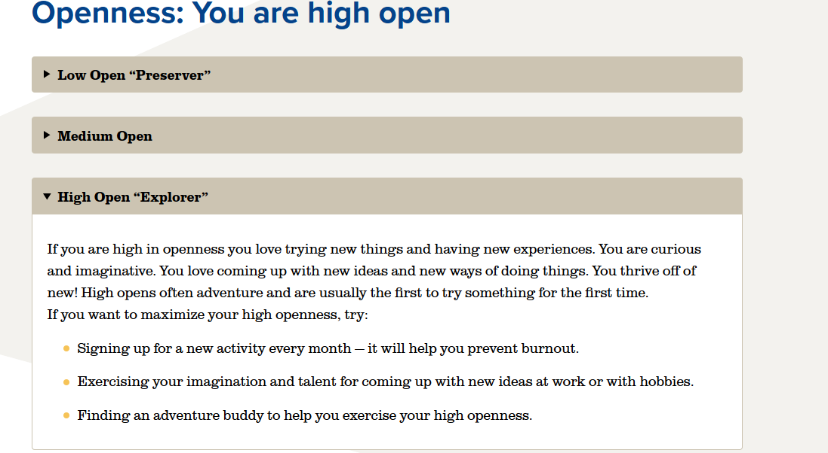

**Morgan Cassar**

*Myer-Briggs Test*

[*https://www.16personalities.com/istp-personality*](https://www.16personalities.com/istp-personality)



*Learning Style Test*<http://www.educationplanner.org/students/self-assessments/learning-styles-quiz.shtml?> 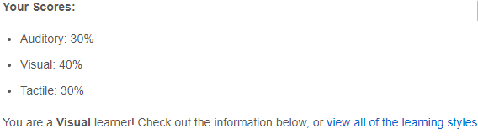

### 

*The Big Five Personality Test*[*https://www.truity.com/test/big-five-personality-test*](https://www.truity.com/test/big-five-personality-test)

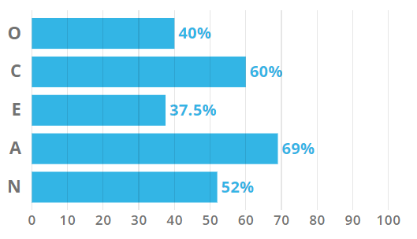

**Comments**

**Robert Cross:**

**Ryan Williams:**

**Benjamin King:**

**Douglas Baker:**

**Ty Lynch:**

I think that it is interesting that Douglas and I share the same results in the 16 personalities test which means we could either but head or work together quite well. Morgan and Ryan seem like they will make good team members willing to get in there and lend a hand where they can while also allowing others to have their freedom and collaborate on their tasks also. Benjamin’s 16 personality test mentions him being soft-spoken but from what I have seen so far, he is quite the leader organising the group in a fair and orderly manner. While it also seems Robert will make a good leader from his Myer-Briggs style test and his selection of job role.

**Morgan Cassar:**The fact that me and Ryan share the same result on our 16 personalities test means that I think we would work well together due to our personality type, being someone who is willing to work together on things towards a goal. Douglas and Ty, also share the same personality result, they are responsible people, and from what I can gauge from what they have done for this assignment, they have been very responsible, calm and practical and worked well with everyone in the group. Robert seems to have the personality who is dedicated, which he has shown through this assignment. Bens personality describes him as insightful and decisive, which he has definitely shown throughout this assignment.